**Project Title:Exploratory analysis of rainfall data in India for Agriculture Project Design Phase-I** - **Solution Fit Template**

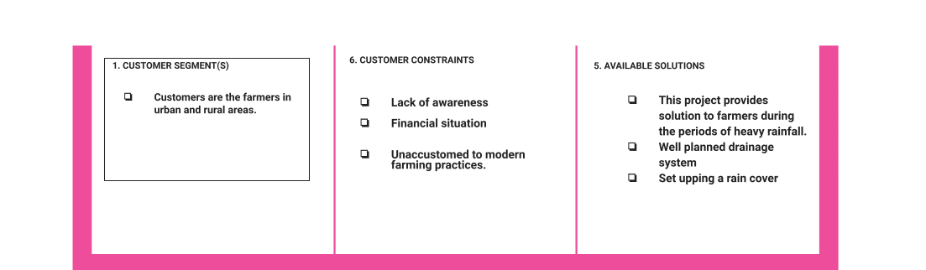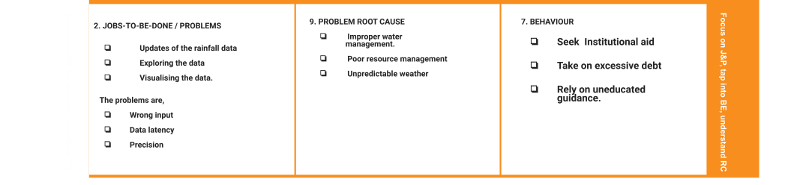

**Team ID:** PNT2022TMID40687

|  |  |  |  |  |
| --- | --- | --- | --- | --- |
|  | **3. TRIGGERS**     * **The Triggers of this project are,** * **Repeated financial loss and** * **Poor yield** | **10. YOUR SOLUTION**     * **Our historical rainfall data.**      * **Predict the rainfall pattern for a given period.**      * **Categorize the intensity of rain.**      * **Develop a webpage to provide necessary guidelines for farmers.** | **8.CHANNELS of BEHAVIOR**  **The Channels that support behaviors are**   * **Proper Visualization of data** * **Choosing correct data** * **Proper marketing and advertising** |  |
| **4. EMOTIONS: BEFORE / AFTER**  **Before: Panic in case of excess rainfall oncers regarding results in damage of crops and financial hardships.**    **After: can easily know the amount of rainfall in advance** |